Activity: Generate a G-Code program with slic3r open source s/w and visualize in pronterface open source application. We will use the STL file generated in the previous Key Fob activity. We will need to adapt the file since Shapeways stores STL files in inches while slicer prefers them in mm.

1. Download and install printrun/pronterface/slic3r from <http://reprap.org/wiki/Printrun>. These are all bundled together.

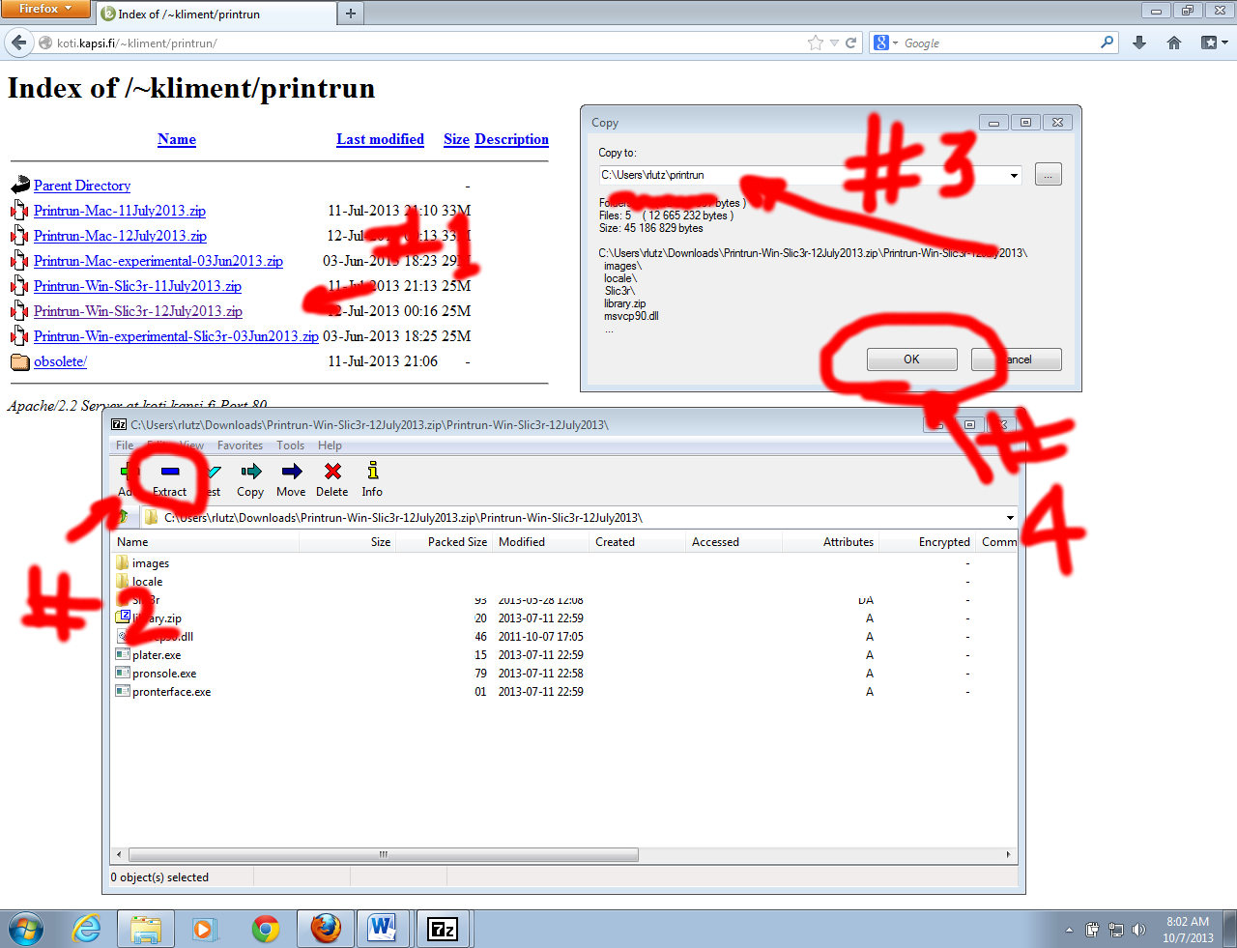

1. Normally, we would set up slicing options specific to the printer we are using. This is done under Settings -> Slicing Options in Pronterface. Since we’re only going to slice our mode and validate the tool paths, we’ll skip this step.
2. Install MeshLab. Navigate to http://meshlab.sourceforge.net. Click on the download link. Then pick your version:

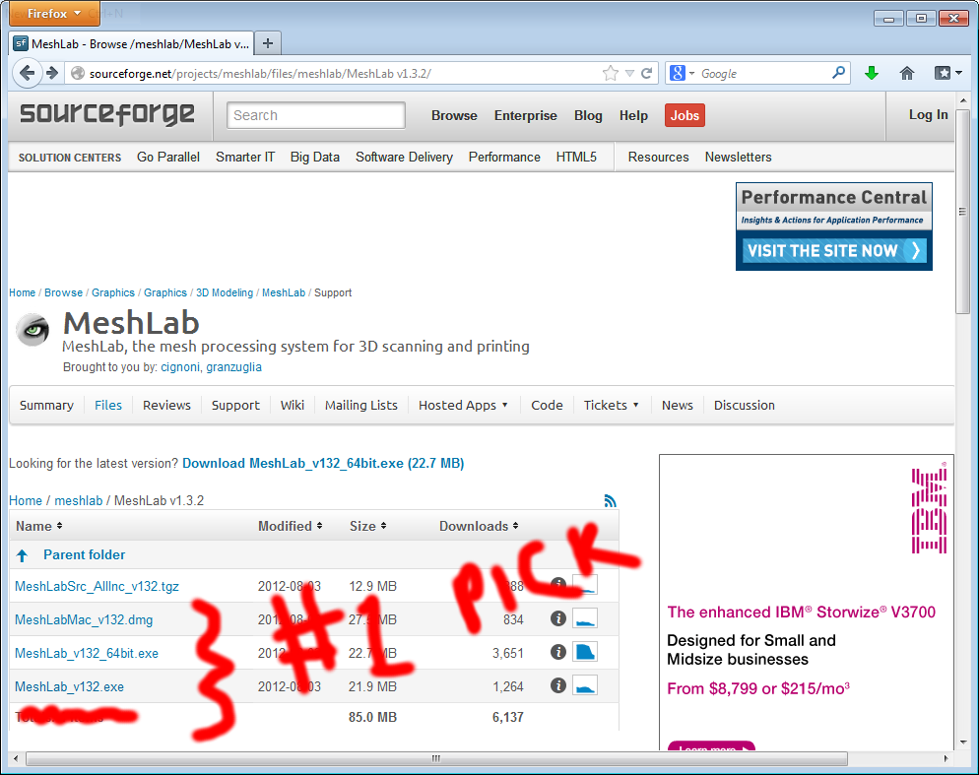

1. ~~Download your model from ‘My Models’ on the Shapeways site. This will be a zip file.~~
2. ~~Unzip the downloaded file, you should find one enclosed STL file.~~
3. For SIGITE,use this [zip file](https://github.com/rjlutz/3DPrinting/blob/master/Activities/Keychain%20Fob/Artifacts/output.stl.zip).
4. Open Meshlab and read your STL file with File -> “Import Mesh…”

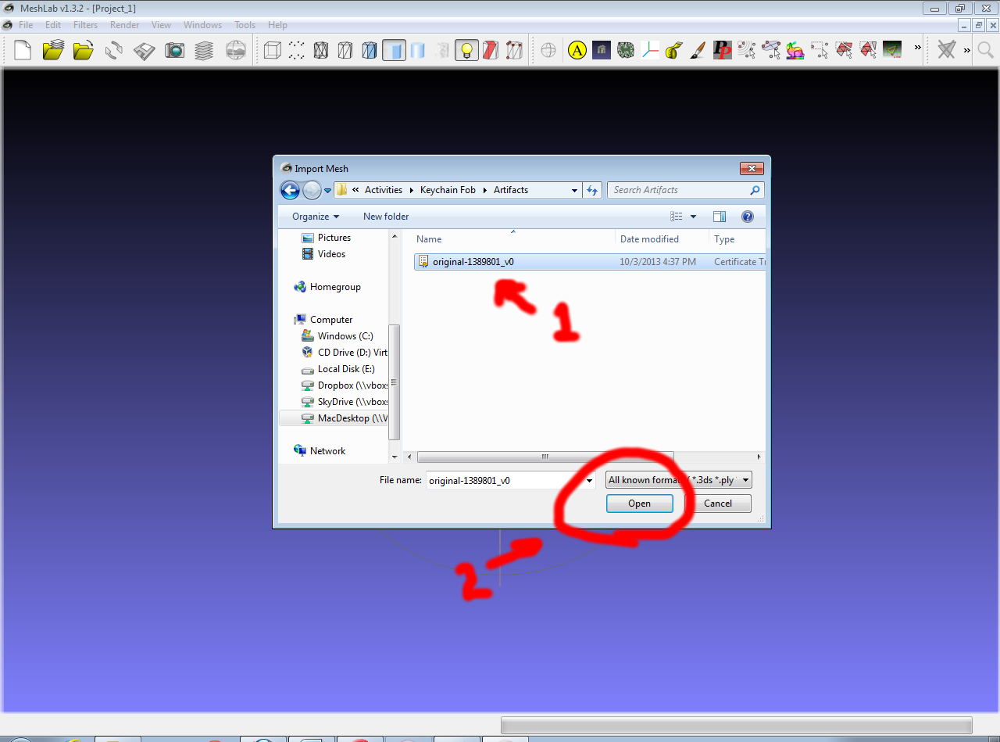

1. Navigate to the Transform Scale Menu:

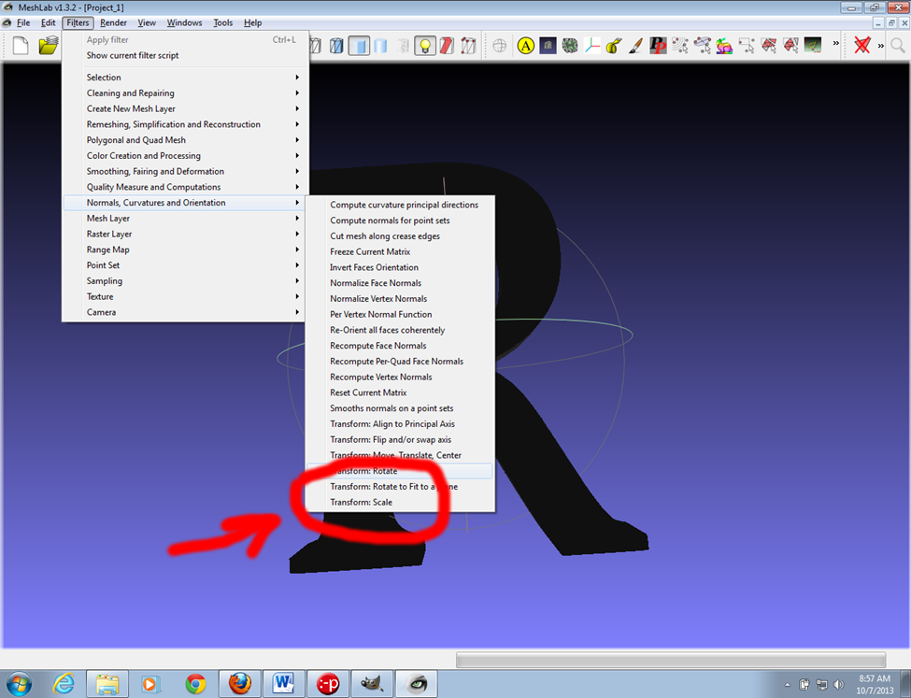

1. We need to scale the model by 25.4 to convert from inch units to mm. The scale tool will only scale by 10x, so we’ll need to do this in two steps:

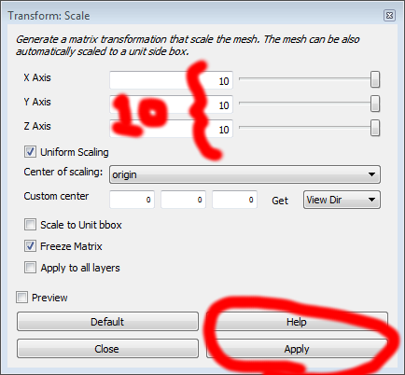

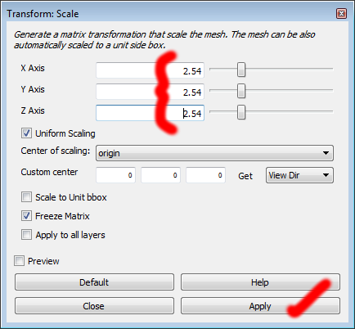

1. In Meshlab, navigate to File -> Export Mesh … to save your transformation. It’s ok to overwrite your initial file. Optionally, you can rename the output to something else.
2. Open the STL model file in Pronterface:

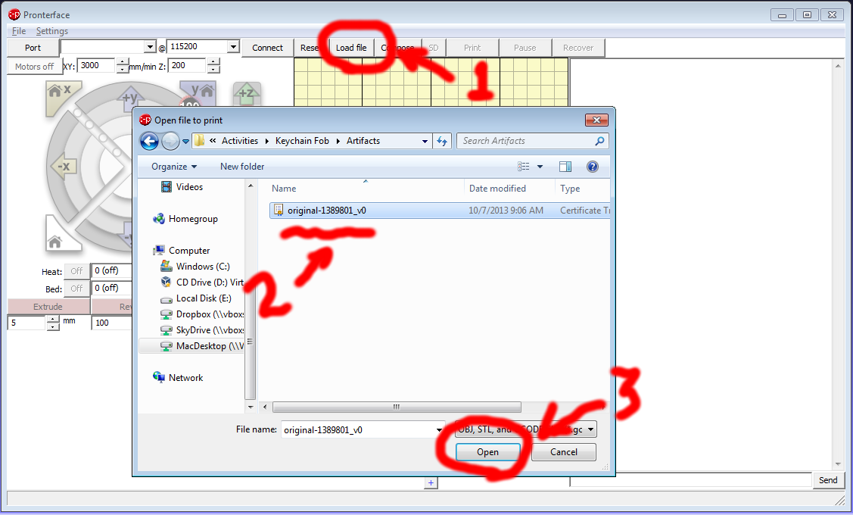

1. Check to see that you model was successfully loaded:

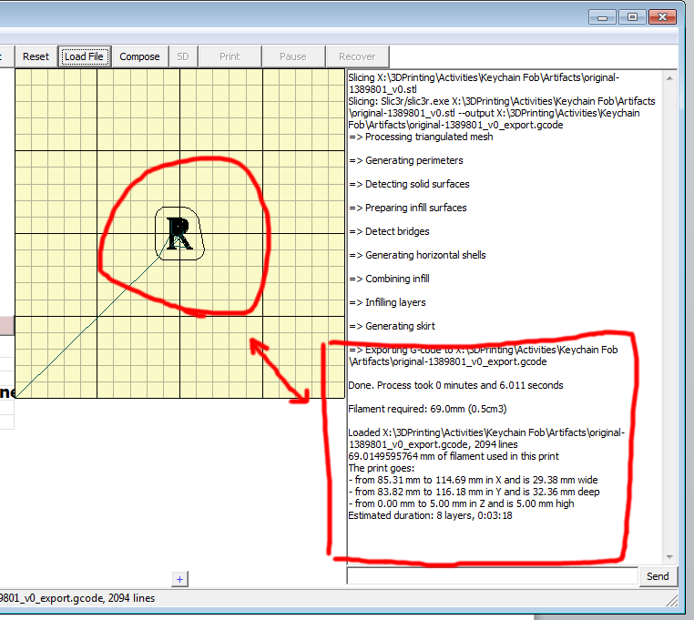

1. In Pronterface, single click on the light yellow graph paper section to examine the layers of the G-Code file. A popup window will appear.
2. You can use the controls at the top of the popup to cycle through the layers in the program. Alternatively, you can hold shift and rotate the mouse wheel to quickly cycle through the layers.
3. Next, view the G-Code file. You can find the path and filename in Pronterface’s text pane (as shown above in Item 11):

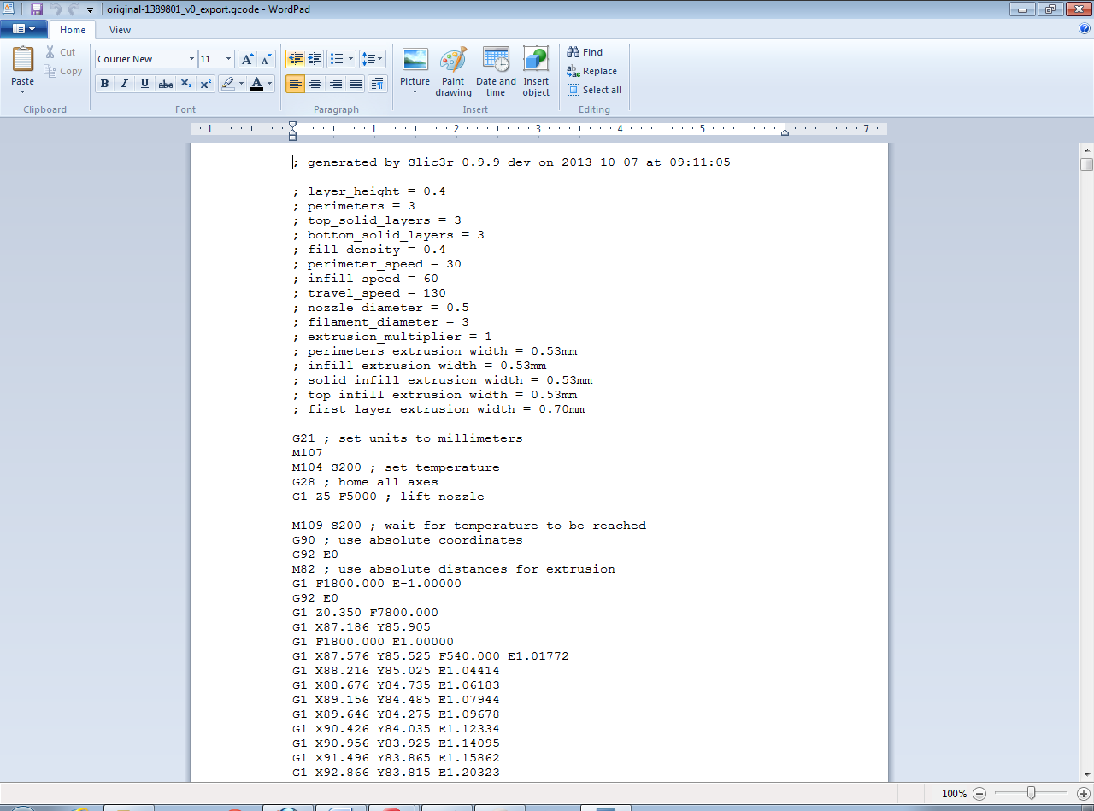

1. Success! We’re done!